Year 9 Speed, Pressure & Moments Part 1 - Learning Journey
Lesson | Oi! Remember this!
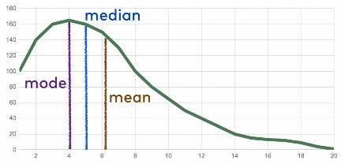  1.) Averages | Calculating Mean, Mode and Median
2.) Calculating uncertainty | Maths skills in general
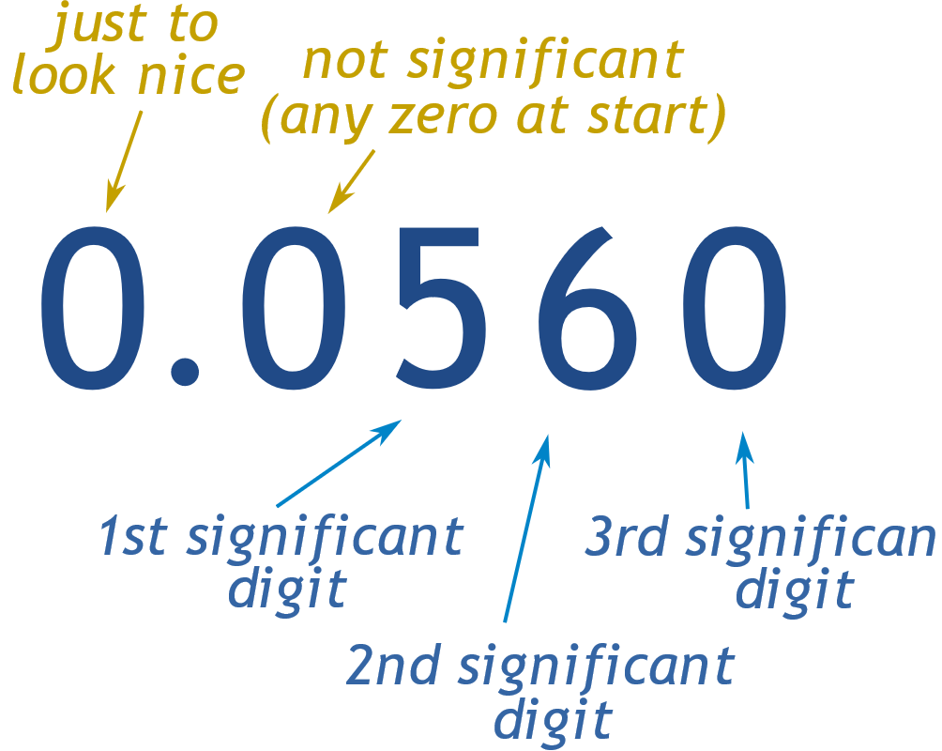  3.) Significant figures | Rounding up or down
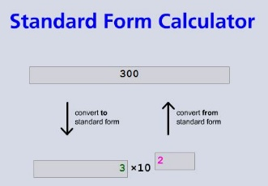  4.) Standard form | Maths skills
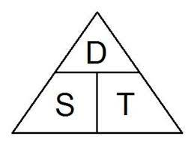  5.) Speed equation | How to write an equation; s=d/t
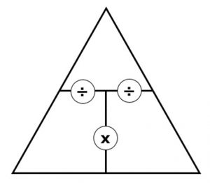  6.) Using Equation triangles | Rearranging equations
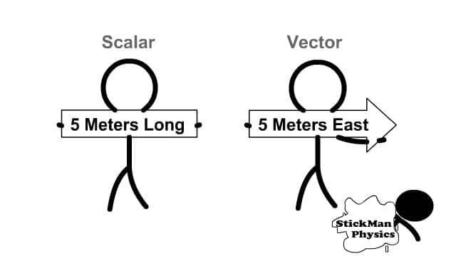  7.) Scalar and Vector | Speed and Velocity are different
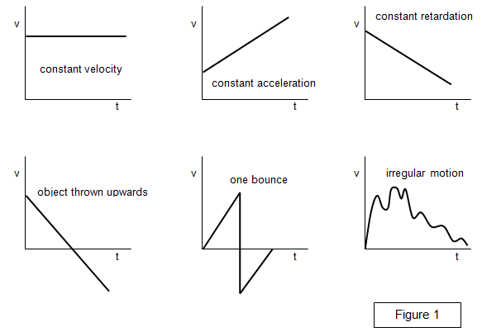  8.) Patterns in graphs | Straight lines = constant,  curves = changes
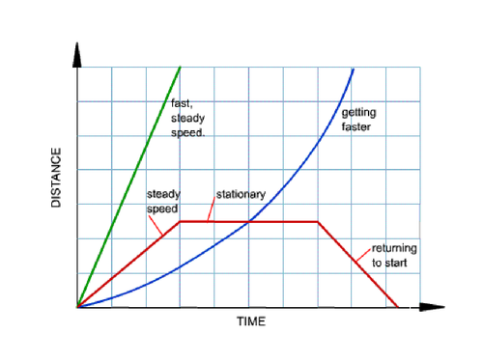  9.) Distance/time graph | Rules for d/t graphs…

