Year 9 Genetics - Learning Journey
Lesson | Oi! Remember this!
1.) Specialised Animal and Plant Cells | Cells become specialized to do a particular job
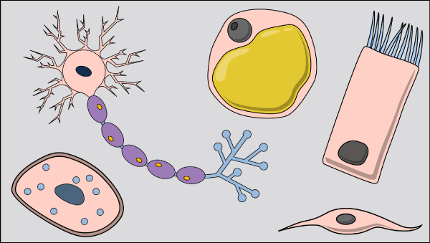
2.) Organisation of Organisms | Build bodies from Cells to Tissues, to Organs to Organisms
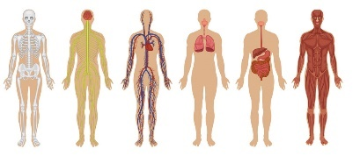
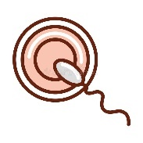  3.) Fertilisation | Fusion of nuclei = 1 cell
4.) Continued Development | Development continues by cells dividing
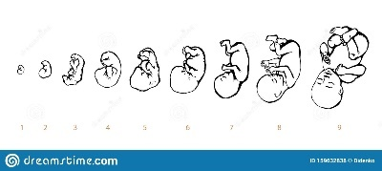
5.) Inherited and Environmental characteristics | There are two types of variation
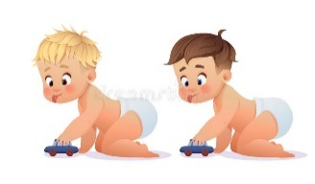
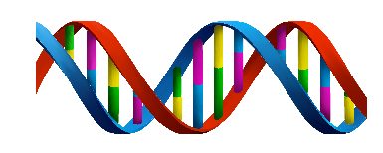  7.) D.N.A. discovery (Franklin, Watson &Crick) | DNA is code, one gene = one protein
8.) Inheritance of Genes | Characteristics depend on pair of genes
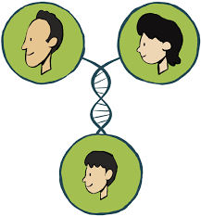
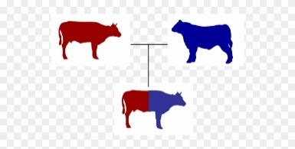  9.) Selective breeding | Human chooses which animals breed for particular characteristics
10 & 11.) Cloning and Ethics of cloning  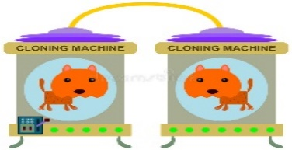 | Using ideas about development to make lots of copies of the selected animal/plant  Year 7 – Cells (Cells to Organs), Life (Fertilisation & Development)  Year 7 & 8 - Variation
12.)Synoptic Assessment

