Year 8 Sound - Learning Journey
Lesson | Oi! Remember this!
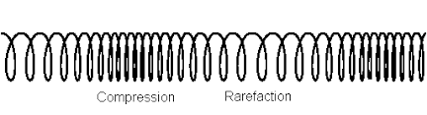  12.) Compare wave types | Sound and Light waves are different types of waves
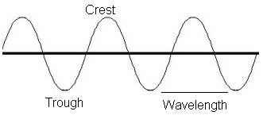
13.) Speed of Light and Sound | We can measure wave features
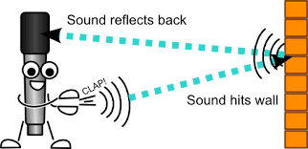
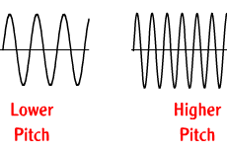  14.) Frequency and Amplitude | Different wave features make different sounds
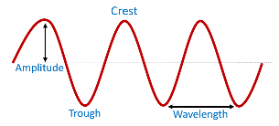
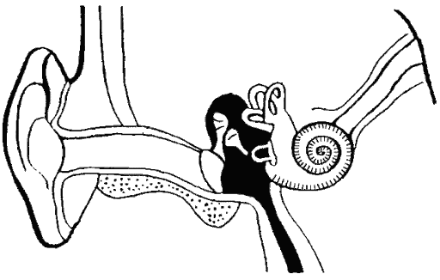  15.) Human Hearing | Sound is all due to vibrations; we hear because these are transmitted
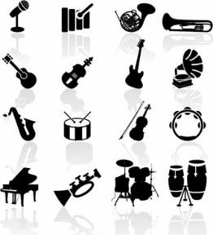  16.) Musical Instruments | Sound is all due to vibrations; we can control and change features of the wave
17&18.) Sound Insulation
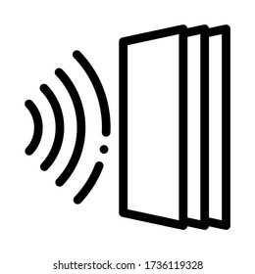 | Year 7 – Energy (types of energy)  Year 7 – Body Systems (Sense organs, the eye, nerves)
Synoptic Assessment Exam 1

