Year 8 Magnetism - Learning Journey
Lesson | Oi! Remember this!
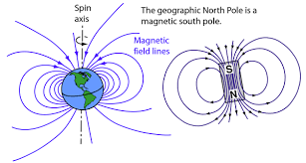  1.) Making a compass | The Earth is a huge Magnet with fields of force.
2.) Effects of Magnets | Magnetic Force is in fields.
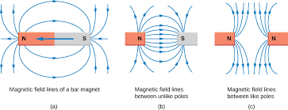 | They attract and repel.
3.) Making Electromagnets | When current flows a magnetic field is produced.
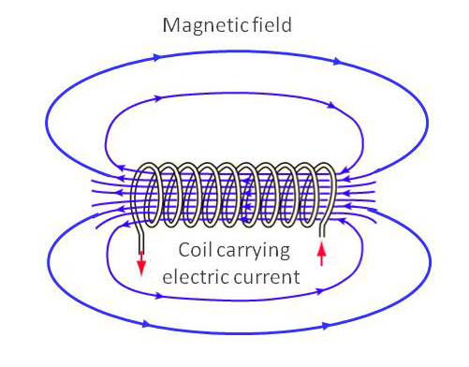
4-5.) Investigating Electromagnets | We can alter the strength and polarity of an Electromagnet.
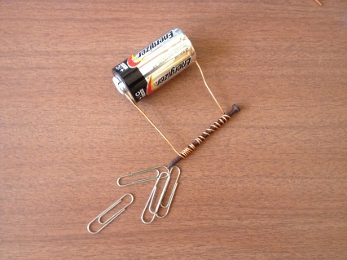
6.) Explain how Electromagnets work | The more Domains aligned the stronger the magnet.
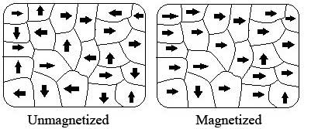 | 7 – Electricity (current, voltage)  7 – Forces (magnetic force, attraction, repulsion)
Exam 2 Assessment

